Evaluating the Accuracy, Fairness and Stability of Interpretable Machine Learning for 30 Day Hospital Readmission Prediction

A Project Portfolio Report submitted in partial fulfilment of
the requirements for the Degree of
Master in IT

at
Whitecliffe

By
INDRACHAPA UMAYANGANI ELANAYAKE
20250845

Supervisor: Mr Tasawer Khan
Co-supervisor: Prof Shahbaz Pervez Chattha

Whitecliffe, New Zealand
2026

Abstract
Add your title
by
Add your name

Put your abstract here. (The abstract will not be longer than one page )

Keywords: Put your Keyword here (between 8 to 12 )

Dedication/Acknowledgements
To my ????, I dedicate this work

Table of Contents
Abstract iii
Dedication/Acknowledgements iv
Table of Contents vi
List of Tables vii
List of Figures viii
1 Introduction 1
1.1 Background of the study 1
1.2 Problem Statement 2
1.3 Research Questions 3
1.3.1 Research Question 01 3
1.3.2 Research Question 02 3
1.3.3 Research Question 03 3
1.4 Research Objectives 3
1.5 Significance of Study 5
1.6 Project Report Organisation 6
2 Literature Review 8
2.1 Related Work and Readmission Prediction 8
2.2 Machine Learning Models and Clinical Baselines 9
2.3 Fairness in Healthcare Prediction 11
2.4 Explainability and Interpretable Machine Learning 12
2.5 Calibration and Evaluation 13
2.6 Ethical and Cultural Context 14
2.7 Research Gap 15
2.8 Summary 16
3 Method 18
3.1 Study location and Data Source 18
3.2 Study Design 18
3.3 Data collection and Cohort Construction 19
3.4 Data Preparation and Leakage Control 20
3.5 Models and LACE benchmark 21
3.6 Evaluation Measures 22
3.7 Fairness and Mitigation Analysis 23
3.8 Explanation Analysis 25
3.9 Ethical Consideration 25
4 Data Analysis and Results 27
4.1 Cohort and Descriptive Results 27
4.2 Model Performance 27
5 Discussion 30
5.1 Results Discussion 30
5.2 Comparison with previous studies 30
5.3 Answer Objective 1 30
5.4 Answer Objective 2 30
5.5 Answer Objective 3 30
5.6 Summary 30
6 Conclusion 32
6.1 Limitations 32
6.2 Contribution 32
6.3 Future work 32
References ( APA style ) 33
Appendix A 34
A.1 Human Ethic Committee approval (if applicable) 34
A.2 Consent Form (if applicable) 34
A.3 Questionnaire (If Applicable) 34
A4 Interview Questions (If Applicable) 34
Glossary 35

List of Tables

Table 1: Comparison between exisiting systems 16
Table 2: Cohort explanation 19

List of Figures
Figure 1: Cohort construction and patient-disjoint evaluation workflow 18
Figure 2: Missing values before final cohort 20
Figure 3:Missing values after final cohort 21
Figure 4: StratifiedGroupKFold cross-validation 22
Figure 5: Global threshold seelction 25

Chapter – 01
Introduction

Introduction

Background of the study
Hospital readmission is an outcome with implications for patients, families, hospitals and health systems alike. An early return to hospital following discharge may indicate ongoing disease, complications, incomplete healing, inadequate discharge planning or inability to access external help (Abdelhalim A, 2024). Readmission is not just a proxy for poor quality of care: it also results from illness severity, access to care, socioeconomic determinants and organization of health care services. Thus, a prediction model is capable of estimating risk within a certain data and services context, but it is not sufficient per se to identify preventable readmissions or show efficacy of any intervention.

EHR data allow for incorporating demographics, diagnoses, medications, utilization and administrative variables into one dataset. It is still worth considering statistical regression models because they provide interpretable relationship between input and outcome variables. On the other hand, machine learning models have some apparent advantage in modelling nonlinear relations and interactions. However, the latter depends on adequate definition of cohorts, model validation and outcomes. From the point of view of predictive performance, a model cannot be a clinical model without calibration, evaluation of subgroup errors and interpretation of results.

In this project, there is the utilization of the publicly available dataset of diabetic encounters at 130 US hospitals. There will be the use of regularized logistic regression, Explainable Boosting Machine (EBM), XGBoost, and the rebuilt LACE score. This project adds to the comparison a number of parameters including calibration, group true positive rate, explanation patterns, and fairness mitigation techniques. The goal of the project is to find out whether more complex models give any additional value.

Problem Statement
Studies focused on readmission prediction frequently provide discrimination statistics like the area under the receiver operating characteristic curve (ROC-AUC). Though an increased ROC-AUC suggests that the model ranks patients better, it can still provide non-representative probabilities, perform inconsistently across certain demographics, or depend on variables whose importance is hard to justify. Furthermore, different cohorts, outcomes periods, validation approaches, and data sources may be used in different studies, complicating the comparison of reported performance metrics. This research has a particular issue with the use of repeated patients in the dataset: if data about the same patient are included in both training and testing datasets, the performance will seem higher than it really is because the model has already learned from that patient.

The study in question tests models trained and tested on separated patient data and considers several performance metrics. The diagnostic dataset contains 98,493 rows for the X, y, and groups datasets after alignment of the group array, while the split does not contain patients in common.

Research Questions

1.3.1 Research Question 01
How well can 30-day readmission be predicted, does a machine-learning model beat plain logistic regression, and which patient factors most influence its predictions?

1.3.2 Research Question 02
Does the model perform equally well for every age, gender and race group, and do the explanations behind its predictions look the same for each group?

1.3.3 Research Question 03
Can standard fairness methods close the gaps, what does that cost in accuracy, and does making the model fairer change what the model says is driving its prediction

Research Objectives
The aim of this analysis is the assessment of the predictive performance, calibration, fairness, and explainability behaviour of selected models predicting 30-day readmission of adults present in the Diabetes 130-US Hospitals dataset.
- Fit and compare the penalised logistic regression model, an EBM, and XGBoost to 30-day readmission prediction task.
- Compare the above models with an adjusted LACE score, specifying all deviations from the original clinical scoring system.
- Assess discrimination and threshold classification abilities, as well as calibration, using ROC-AUC, PR-AUC, sensitivity, specificity, positive and negative predictive values, Brier score, calibration intercept, and calibration slope.
- Evaluate performance differences between age, gender, and racial subgroups, focusing particularly on equal opportunity and confidence intervals.
- Use SHAP values to summarise XGBoost importance, compare subgroup-level results, and test stability of global feature importance ranking on different samples.
- Evaluate race-based reweighing and race-based threshold adaptation, assessing fairness metrics and predictive performance.

Research Question | Main Objective | Key Evidence
RQ1 | Compare models and adapted LACE | Held-out discrimination, calibration, threshold metrics, global feature importance
RQ2 | Assess subgroup performance and explanations | Group TPR/FPR, uncertainty intervals, subgroup SHAP patterns
RQ3 | Test mitigation methods and trade-offs | Before/after fairness and performance measures; SHAP ranking changes

Significance of Study
The importance of this project is the multi-criteria evaluation approach, rather than the invention of a novel algorithm. The project includes six different techniques in a single reproducible experiment, which are the statistical benchmark, the nonlinear model that is intrinsically interpretable, the boosted-tree model, the reconstruction of a clinical score, the subgroup evaluation, probability calibration, and two fairness approaches. This design is capable of demonstrating the reasons why a slight increase in performance is not always sufficient to add more complexity to the model. Moreover, this approach allows the consequences of a fairness intervention to be quantified in test set metrics and not treated as a property of the method.
The project is relevant to the responsible practice of AI due to the necessity to include the subgroup denominator, uncertainty, calibration, and the threshold selection. The results can be valuable for the future research workflows for clinical risk prediction, but this study does not represent a clinical tool.

Project Report Organisation

Chapter – 02
Literature Review

Literature Review

Related Work and Readmission Prediction
The problem of readmission prediction was addressed using administrative scoring, regression, and machine-learning techniques. The publicly available Diabetes 130-US Hospitals dataset was often employed due to its size and availability, as well as the fact that it includes clinical and utilisation variables. Size provides opportunities for comparison of subgroups and models, but the source represents care in the US between 1999 and 2008. Therefore, the care context, coding conventions, medications, and demographic classifications might not be relevant for today. Big datasets do not solve temporal or geographical limitations.
Strack et al. (2014) explained that the dataset was based on an extract of care during ten years at 130 hospitals. The UCI repository describes the task as identification of readmissions early enough within 30 days and specifies the levels of the target variable. Such information about the sources helps to ensure reproducibility, but the source is not a current prospective cohort, and the labels correspond to encounter patterns in records, not a consistent clinical decision-making. Studies should specify their definition of the target group and outcome, as exclusions and repeated encounters influence both prevalence and task difficulty.
The findings of review papers indicate that readmission modelling outcomes differ depending on the population being studied, definition of the outcome, timing of the predictions, predictors used, and validation approach. For instance, a readmission model validated using an encounter-level split would benefit from sharing patient history between training and test encounters for the case of repeat encounters by the same patient. This would lead to overly optimistic generalization of the model's performance for new patients. The present study attempts to avoid such potential leakage in its approach to splitting using patient identifier data but does not attempt validation for future years or external hospitals.
The problem of translating a statistically significant event into a useful clinical prediction opportunity remains important throughout the literature. A score predicting readmission is not necessarily one which is also useful for an intervention, or even identifying people who have high scores due to factors outside the hospital's control which prevent them from returning to the hospital. Therefore, it becomes clear that the outcome prediction target requires a context for decision making.
Constructing outcomes also impacts performance. In this study, the source considers readmissions in less than 30 days, readmission greater than 30 days, and no readmission at all. Grouping the last two categories together as the negative category is easier to model but may mask distinctions between late readmission and non-readmission at all. Disregarding deaths and hospices alter the population studied and leaves out events that may be considered adverse in some composite outcomes. This is a valid method of research as long as it is clearly stated, although comparisons of the numbers cannot be done to other studies that use different outcome measures.

Machine Learning Models and Clinical Baselines
A 30-day readmission after discharge from the hospital is considered an important healthcare outcome since it may reflect the problems in patient's recovery process, as well as discharge planning and continuity of care. Early identification of patients who are prone to readmission could help healthcare providers deliver more follow-up and preventive measures to them (Dhaliwal & Dang., 2024). In recent years, there have been more examples that have shown the power of machine learning in predicting patients' readmission in 30 days. For instance, Davis S (2024) investigated machine learning algorithms and survival modelling methods by utilizing longitudinal clinical data and revealed the superiority of readmission prediction performance in comparison to models that used only clinical variables. Likewise, Alnazari (2025) applied an explainable machine learning algorithm for predicting readmission in 30 days in hospitals and showed how explainable artificial intelligence can help interpret risks in clinical applications. Hence, readmission prediction in hospitals has become one of the key areas of ML application in clinical practice with growing attention to interpretability.
There have been several studies that used this dataset to build models for predicting 30-day readmissions directly. Specifically, Emi-Johnson OG N. K. (2025) performed the analysis of UCI diabetes dataset by splitting it into 80% training and 20% testing with ROC-AUC scores of 0.667 for XGBoost, 0.642 for logistic regression, 0.630 for random forest and 0.579 for deep neural network. These results were interpreted using SHAP. This study serves as a good benchmarking point but the design of their study cannot guarantee patients' separation. As the source dataset has repeated observations of each patient, the split into random observations may include patients' data into both training and testing datasets. Liu VB (2024) likewise works on the diabetes readmission dataset from the UCI and has found about 0.64 AUROC for XGBoost, while the logistic regression and random forest algorithms follow suit. In their methodology, they employ feature selection, resampling, and employ grouped folds to ensure that all entries belonging to the same patient appear in one-fold. From a methodological perspective, this is relevant since it takes into account the within-patient dependence. Nonetheless, their focus is mainly on the classification task and not on the combination of analysis elements provided herein. Careful comparisons should be made due to the fact that feature selection, synthetic oversampling, folds design, and the holdout method affect the result.
Clinical risk scores have been used for this kind of predictions traditionally. For instance, the LACE index considers such factors as length of stay, admission acuity, presence of comorbidity and emergency department visits before admission as predictors of the probability of readmission (Dreyer, 2026). The HOSPITAL score represents another well-established clinical prediction tool for potentially avoidable readmissions. They serve as good examples due to their clear set of variables and scores. However, due to the simple nature of their structures, they may fail to account for complicated relationships in modern EHRs. Recent studies support this claim, with one done in 2025 comparing LACE score with traditional logistic regression and various machine-learning techniques and finding that the nonlinearity between clinical predictors is likely to negatively affect the predictive capacity of traditional methods (Sharma Y, 2025). Thus, machine learning offers the potential to utilize more EHR variables and detect more complex relationships compared to conventional clinical risk scores.
Another solution offered by machine learning is to learn the association between patient characteristics and outcomes through historical data. Some common machine learning methods used for prediction tasks are logistic regression, decision trees, random forests, support vector machines, gradient boosting approaches, and neural networks. One example is a meta-analysis published in 2023 which compared advanced ML approaches with logistic regression regarding the task of 30-day readmission prediction (Ashna Talwar, 2023). According to the results, machine learning approaches could deliver comparable predictions compared to logistic regression, while the advantage over logistic regression was not always significant in different studies. This finding is critical since it disproves the idea that more complicated models will lead to meaningful improvement in the prediction.
More recent systematic reviews confirm the high interest in ML-based readmission prediction; however, they point out some problems connected with generalizability, methodological quality, and clinical implementation. For instance, Zain Y (2024) aimed at examining ML models predicting 30-day readmission of patients with multiple illnesses shows the high variability in datasets, models, and predictors used, which indicates the dependence of model performance on specific clinical population and data sources. In another recent review of readmission prediction research, researchers have noted the potential for improving generalizability and interpretability of the results (Sharda M, 2025). Additional information on the methodological weaknesses was provided by Selmer N (2025) who discovered that the majority of the analysed readmission prediction studies had a high level of potential bias specifically at the analysis stage, in spite of showing a moderate degree of prediction.
It means that the research question should not be limited to the problem of selecting the most accurate ML model. The clinically meaningful algorithm should also be able to generate valid probabilities, work well with various patient populations and generate interpretable information.

Fairness in Healthcare Prediction
Fairness can be assessed even without altering the model, but it can be done using fairness aware decision thresholds as well. For instance, a typical approach is for a machine learning model to predict the probability of readmission and then make decisions by using a certain threshold to determine whether the patient belongs to the category of high or low risk.
For example, the threshold may be set at 0.50 for identifying a patient as having a high probability of being re-admitted. By altering the threshold, the number of patients who will be identified as having a high probability of being admitted varies and hence, alters the true positive and false positive rates. As a result, threshold selection may greatly influence fairness metrics like Equal Opportunity, which emphasizes the importance of equal identification rate of those experiencing the outcome regardless of their demographic group. This relationship has been empirically proven in hospital readmission prediction. Kharrazi (2024) analysed 30-day hospital readmission prediction models for different racial and income subgroups and found large discrepancies in false negative and false positive rates across the populations. Similarly, Wang (2024) showed that threshold alteration in 30-day hospital readmission prediction models results in a compromise between achieving fairness and the overall prediction accuracy. Moreover, a 2025 study used threshold calibration based on subgroup data to address the problem of Equal Opportunity Difference in a real-world readmission prediction and showed that while reducing the discrimination, threshold adjustment influences other factors as well, including accuracy and number of people targeted for intervention (Mackin S, 2025).
Recently, there has been empirical support for the idea that threshold selection can result in a trade-off between fairness and overall performance of the algorithm. Specifically, Wang (2024) studied various risk thresholds for hospital readmission algorithms and demonstrated how threshold variations could lead to a trade-off between fairness and overall performance. Similarly, Wang HE W. J. (2024), examined the presence of bias in commonly used 30-day hospital readmission models and raised awareness about the possibility of disparities in the model’s performance based on race and socioeconomic status. The study stressed that fairness can only be evaluated through its implications on how risks are used to distribute interventions in health care.
But it is important to note that thresholding cannot simply be taken to mean an improvement in the probability calibration of the model because probability calibration involves the actual predicted probabilities and not the thresholding itself. Thresholding could lead to improvement in the classification-based metric of fairness but could alter sensitivity, specificity, and the number of patients chosen for the intervention. Hence, in the proposed study, it is important to test whether fairness-aware thresholding can lead to improvement in Equal Opportunity without increasing discrimination and probability calibration.

Explainability and Interpretable Machine Learning
Explainability is yet another problem associated with ML in health care. The use of complex models, for instance, gradient boosting and random forest, can lead to very high predictive power but low direct interpretation of how certain predictions were made. Therefore, such explainability tools as SHAP (SHapley Additive exPlanations) and LIME became quite popular as a solution to the problem.
One such advantage of SHAP is its ability to quantify the importance of each individual feature in a model prediction. For example, SHAP can detect whether the presence of previous hospital admissions for a patient increases their chances of being readmitted, whereas other features reduce their chances. Such an explanation is capable of offering a global view of the factors affecting model behaviour, as well as a local explanation for an individual patient. It has been observed in recent research that explainability can be helpful in identifying any unusual relationship between the model and data (Burns S, 2024). SHAP was likewise used by (Huberts LC (2024) for interpretation of the gradient boosting model for predicting hospital readmission through the use of Shapley values for determining the factors that influence 30-day and 180 day readmissions.
However, one should keep in mind that explainability does not always mean trustworthiness. In their recent paper, Ghassemi, Oakden-Rayner and Beam (2021) state that XAI solutions may provide false confidence in health care and that explanations do not guarantee better decision making and safety. In addition, according to Rudin (2019), it is recommended to use inherently interpretable models whenever high-stakes applications allow it rather than using explanations of black-box models. This is especially relevant to the suggested research since the use of penalised logistic regression and other inherently interpretable models can become alternatives to black-box models.
The recent research of hospital readmission has shown that interpretable machine learning models can be constructed for hospital readmission prediction. For instance, Gao X (2023) presented an approach of interpretable modelling which involves extraction of regression tree. It shows that the model can be constructed using the technique of interpretability rather than explaining predictions. Similarly, Ruiz de San Martín R (2024), designed an interpretable machine learning framework for the early prediction of unplanned hospital readmissions. This study showed how both global and local interpretability methods could be applied to find out the factors that play a role in making readmission predictions possible, and thus provided not only the predictions themselves but also their features.
In their research, Lv J (2023) proposed a method that enables explaining predictions by utilizing the machine-learning-based technique for 30-day hospital readmission following stroke. In the research, SHAP was employed to interpret model predictions and identify the most impactful risk factors. 11 Thus, the suggested research will not just construct SHAP plots and claim the explainability of the model. On the contrary, the study will compare black-box models with the inherently interpretable model and examine the explanation stability. If minor changes in training data lead to major differences in explanations, the confidence in the explanation is lowered.

Calibration and Evaluation
Discrimination assesses whether a classifier ranks positives higher than negatives. ROC-AUC is less affected by the frequency of outcomes, while precision recall area is informative in case of rare positives and its baseline depends on prevalence. However, neither ROC-AUC nor PR-AUC provide information about numerical quality of an estimate. The Brier score represents mean squared error of probability estimates and combines calibration and discrimination aspects of a prediction. Calibration curves show the relationship between average predicted probabilities and outcome frequencies in bins. Intercept and slope describe overall calibration and over/under dispersion and have to be calculated with caution.
Threshold metrics depend on threshold chosen for making a prediction. At some fixed threshold, sensitivity, specificity, positive predictive value, and negative predictive value correspond to different practical questions. Given the outcome frequency of 11%, the value of PPV will still be low in case of modest ranking capacity of a classifier. Reporting accuracy is especially confusing since at an extreme imbalance a classifier that predicts almost all observations as negative will still be very accurate. That is why reporting ROC-AUC, PR-AUC, Brier score, threshold metrics, subgroup TPR, and calibration plots is obligatory.
These metrics complement each other rather than substitute each other. The ROC-AUC metric calculates ranking accuracy across thresholds that will possibly never be used practically. PR-AUC focuses on positive labels but is sensitive to prevalence, thus making comparisons across groups difficult. The Brier score is a proper scoring metric for probabilistic predictions, but its usefulness depends on the prevalence of the outcomes and does not reveal subgroup calibration issues. Calibration plot helps detect nonlinearity or local problems with calibration that a single metric cannot reveal, but binning adds sampling noise and can lead to instability of small group plots. It is thus necessary to provide all of this information together with the metric.
Calibration intercept and slope should also be interpreted carefully. Ideally, calibration would entail zero intercept and slope equal to one based on the logistic recalibration model fit. The presence of nonzero intercept means there is systematic over-prediction or under-prediction, while the slope less than one usually implies overly extreme predictions. The results show that these statistics on the test dataset for the original models, and this is fine as a descriptive out-of-sample diagnostic but should not be used for re-fitting models knowing their test performance. It should also calculate them for the calibrated XGBoost, since the report compares the calibrated Brier score of XGBoost against those from other models. Calculating recalibration parameters on test datasets renders the test set not an untainted evaluation set anymore; this point should be highlighted.
Evaluations are also dependent on the level of analysis chosen. The event occurs at the level of an encounter, while clinical interventions occur at the level of the individual. Those individuals with many encounters have more records and may affect the model fit as well as the evaluation metrics at the level of the encounter. The grouped split ensures that each patient is in only one group and does not ensure the independence of the observations within the training set. The confidence intervals must retain the patient as the sampling unit. Another patient-level analysis in the future might consider one encounter per patient.

Ethical and Cultural Context
Prediction models can influence access to limited resources, the scheduling of follow-ups, and how much attention is paid. An ethical assessment will have to address the issues of data reduction, secure handling, clear limitations, subgroup testing, human involvement, and post-deployment monitoring. In the current project, there is no need for direct engagement with patients or their recruitment since the data are publicly available and de-identified. This does not mean that the Institutional Review will not be necessary or that the data should be handled irresponsibly.
This data originates from the United States and cannot form the foundation for any claims regarding Māori, Pacific peoples, or New Zealand health systems. If the study was to be continued using New Zealand identifiable health information, privacy and health information governance issues would have to be considered. The Health Information Privacy Code (Commissioner, 2020) controls how health organizations collect, store, use, and release identifiable health information in New Zealand. In addition, if a future project used data from the Māori, it should have been set up with the appropriate Māori governance advice in mind.

Research Gap
The literature review indicates that 30-day readmission prediction was performed with statistical, machine learning, and clinical scores. Explanation and fairness metrics were also considered. Emi-Johnson et al. report results of multiple models along with SHAP, while Liu reports group-level validation due to patients' repetition. A further gap concerns the way how models are evaluated. The metric of discrimination does not indicate whether the predicted probabilities are valid, what readmission identification capacity of the model is across subgroups, and whether its explanations are stable. Fairness and explainability studies covered in literature are essential to answer some of the questions mentioned above. But the results of these studies do not allow concluding that the selected model outperforms other options according to all the criteria mentioned above simultaneously. That is why the paper evaluates penalised logistic regression, Explainable Boosting Machine (EBM), XGBoost and modified LACE score in terms of ROC-AUC and PR-AUC, probability calibration, sub-group performance by age, gender, and race, bootstrap confidence intervals of sub-group true positive rates, and XGBoost explanation stability.
The study also looks at fairness interventions through threshold decisions and reweighting by subgroups. It becomes clear why such methods have to be looked at as trade-offs because their impacts did not uniformly apply to demographic subgroups and metrics of performance. The value of the study is in its combined analysis within the framework of literature analysed here, rather than the novelty of any of the methods or measures used.

Summary

Chapter – 03
Methods

Method

Study location and Data Source
The study is computational and uses the publicly available “Diabetes 130-US Hospitals” dataset, which captures the inpatient treatment of diabetes for 130 US hospitals and integrated delivery networks between 1999 and 2008. This study does not take place at a participating hospital and involves neither patient enrolment nor intervention. There are 101,766 observations and 50 variables, including identifiers, demographics, diagnoses, medications, encounter characteristics and readmission status. (Irvince, 2014).

Study Design
The methodology involves the use of a retrospective quantitative predictive modelling design. The unit of analysis is hospital encounters. If the value for readmission in the dataset is "<30" then the outcome is coded as 1 while a value of either "NO" or ">30" for readmission will be coded as 0. The operational definition of the outcome variable is on an encounter level and not a first-ever readmission outcome at the patient level.
The data analysis workflow includes; data audit, outcome and cohort creation, creation of train, validation, and test splits on patient grouped data, preprocessing and model fitting, internal model selection, calibration, threshold selection, testing set evaluation, subgroup audit, mitigation comparisons and explanation analysis. Figure 1 shows the cohort saved and split numbers.
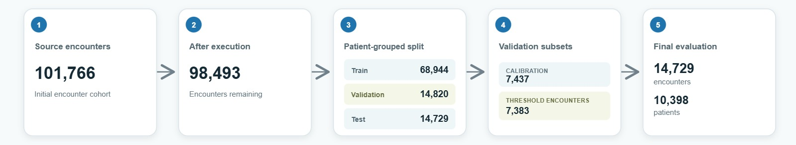
Figure 1: Cohort construction and patient-disjoint evaluation workflow

Data collection and Cohort Construction
No new participant data were collected for this project. The original CSV file was imported into pandas. The special character “?” was replaced by missing values. The weight variable was dropped since 96.86% of the original data were missing it. Death and hospice encounters were recognized based on discharge disposition codes 11, 13, 14, 19, 20, and 21. 2,423 death and hospice encounters were removed from the dataset. No duplicates of the encounter ID column were found. The two lowest age categories ([0-10), [10-20)) were dropped from the dataset, resulting in 98,493 encounters. Since the original source only contains age ranges, the age range 18 and above from the original proposal cannot be applied here.
Cohort step | Encounter count | Interpretation
Original dataset | 101,766 | All records in the source file.
Death/hospice exclusions | 2,423 removed | Codes 11, 13, 14, 19, 20, and 21.
Duplicate encounter IDs | 0 removed | No duplicate encounter IDs in saved output.
Age-band exclusion | 850 removed | All records in [0–10) and [10–20) excluded; operational cohort is 20+.
Final cohort | 98,493 | 11,271 positive labels (11.44%); 87,222 negative labels (88.56%).
Table 2: Cohort explanation
The final cohort contains repeated patients and there are 71,518 patient identifiers as unique patients among 101,766 encounters and 16,773 patients with more than one encounter in the initial dataset. In the study, patient_nbr was kept solely as a grouping variable, while encounter_id and patient_nbr were not used as features for modelling.
The rationale for exclusion criterion shows a meaningful approach to the problem. Encounters which have death or hospice disposition were excluded because there is no point in comparing conventional 30 days after discharge period for patients who died or went into hospice.
Age exclusion criterion is not just a small detail related to measurements but rather a real-life issue. As per the proposal, patients over the age of 18 should be included in the sample, but data include large categories [0-10) and [10-20). By excluding [10-20), both 18- and 19-years-old will be excluded, while keeping that category in the data implies also retaining children. The chosen criterion can be considered a fair approximation of the intended criterion. The research then uses "age 20 years and over" exclusively.
The race feature contains missing data and imputes missing race as the most frequent category in order to predict with model in some pipelines, while keeping missing race as missing in order to perform subgroup audit. These are two different approaches. In the case of subgroup audit, missing race is reported separately to prevent silent exclusion of encounters, but the model preprocessing strategy may treat missing race differently depending on the estimator.

Data Preparation and Leakage Control
Columns `encounter_id` and `patient_nbr` are deleted from predictors. Patient number is stored independently as a grouping variable. All missing symbols `?` are turned into NULL, while `weight` is excluded since there are 98,569 missing values out of 101,766 observations in the source dataset. Missing rates stay very high for max_glu_serum 96,420 (94.75% of the initial sample), A1Cresult 84,748 (83.28%), medical_specialty 49,949 (49.08%) and payer_code 40,256 (39.56%). For the final dataset, it detects 93,356 missing values of max_glu_serum, 82,102 missing A1Cresult, 48,362 missing medical_specialty, and 38,789 missing payer_code. Numerical variables are median imputed and standardized in the framework of logistic regression, categorical are median imputed based on the most common value and one-hot encoded with unknown categories ignored. A special pipeline is developed for XGBoost without numerical scaling. EBM uses string categories and median numerical imputation.
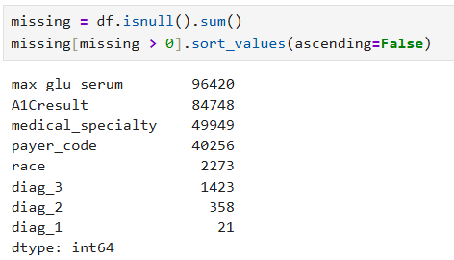

Figure 2: Missing values before final cohort

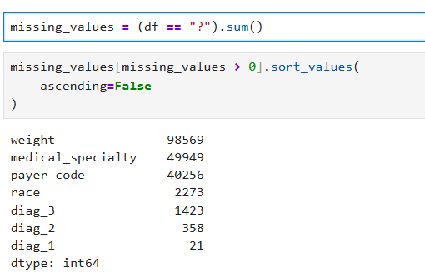

Figure 3:Missing values after final cohort

Preprocessing is fitted using the development dataset and applied to the test partitions. It excluded the outcome and identifier columns from the predictor variables, changes '?' to missing values, excludes the very sparse column 'weight', performs imputation for both numerical and categorical variables, and one-hot encodes the categorical inputs for the linear and XGBoost pipeline. The logistic regression uses scaling for the numeric variables while tree models do not need such scaling. EBM uses the relevant categorical/numerical preprocessing. A leakage test ensures that `target`, `readmitted`, `encounter_id` and `patient_nbr` are removed.
The code creates one filtered analysis data frame and creates X, y and groups based on that data frame and checks the lengths and indexes before splitting. The final modelling dataset has 98,493 observations with 46 predictors excluding `target`, `readmitted`, `encounter_id` and `patient_nbr`; the latter is only included as the grouping variable. The pipeline verifies that the outcome and identifiers are excluded from X, row/index consistency is maintained, and that the patient groups are distinct among partitions. The test datasets have 14,729 observations; the transformed matrix and SHAP results from the XGBoost model each have 14,729 observations.

Models and LACE benchmark
The model set is selected not with the goal of searching the entire algorithmic space, but rather comparing various types of complexity and interpretability. Penalty logistic regression represents a standard parametric approach with the simpler decision-making process. EBM model demonstrates nonlinear feature functions as well as selected interactions but with inspectable functions. XGBoost model demonstrates how the boosted tree learning algorithm works with interaction and threshold capturing that is done automatically. Adapted LACE score is added to the list of models as an example of a concise clinical score rather than a machine learning model.
Penalised logistic regression model is chosen using five-fold StratifiedGroupKFold cross-validation on the training split. Chosen C=0.01 and grouped cross-validation ROC-AUC is 0.6625. EBM is tuned to use 10 interactions, 256 max bins, learning rate of 0.05 and 1000 rounds. XGBoost employs 300 estimators, depth 5, learning rate 0.05, subsampling of 0.8 and 0.8 columns, positive class weighing based on the prevalence in the training set. These settings are the final configurations of the tree-based models and shouldn’t be called exhaustive tuning if no further hyperparameter search was performed. Adapted LACE score is used as a benchmark for ranking performance.
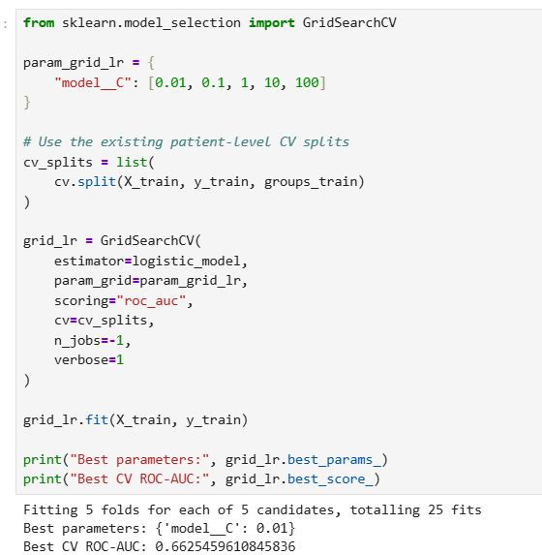
Figure 4: StratifiedGroupKFold cross-validation
Adapted LACE score is based on the length of stay, admission acuity, Charlson comorbidity score adapted from up to three diagnosis codes and number of emergencies. The score is calculated as a single scalar which is then used as a ranking score in ROC-AUC and average precision calculations. The experiment is exploratory and shouldn’t be considered a faithful implementation of the LACE tool.

Evaluation Measures
The test set is withheld from fitting, model selection, calibration and threshold selection procedures. This is crucial since the same patient can appear multiple times in the data set. The random split on the encounter level will enable the model to be trained using one patient’s encounter and tested on another one belonging to that patient, leading to an overestimation of its performance in relation to the defined objective of testing the model on unseen patients. The GroupShuffleSplit split procedure mitigates this problem by allocating all the rows pertaining to a particular patient to the same partition.
ROC-AUC and Average Precision assess ranking. For a certain threshold, Sensitivity (TPR), Specificity, Positive Predictive Value, and Negative Predictive Value measure classification accuracy. The Brier Score measures probability errors. The calibration intercept and slope are calculated through regression of observed labels against the logit of predicted probabilities, ideally 0 and 1, respectively. Reliability plots use quantiles of bins. Thresholds are evaluated at a default of 0.5 threshold and, where possible, a validated global threshold.
Uncertainty associated with the true-positive rate of subgroups is quantified using the patient-cluster bootstrap where the sample chooses the patient along with all their encounters. The report includes the confidence interval of subgroup TPRs and a minimum support rule of 20 positive cases to calculate race equal-opportunity difference. Smaller subgroups are retained for descriptive purposes. The interval is an indicator of sampling variability in the testing data set and does not consider any data source shift or modelling uncertainty.
Average Precision is used because the target event is relatively rare and because this measure pays closer attention to precision-recall behaviour compared to the ROC-AUC measure alone. Baseline of this measure is approximately equal to the event rate, which means that value around 0.24 is meaningfully higher than 0.1145 of test prevalence and at the same time not a sufficient indicator to predict the readmission of a particular patient. Although ROC provides a threshold-free visualization of ranking based on false-positive rates, a very good ROC-AUC may be accompanied by very poor precision if negatives significantly outnumber positives. Finally, Brier Score serves as a complementary measure that penalizes probabilistic prediction errors. Intercept, Slope and Reliability Plots are used for visualization of calibration. This set of measures is deliberately redundant since it provides multiple perspectives on the behaviour of the model. In addition, those measures cannot be interchanged with each other. The research avoids the use of accuracy as the main selection criterion because a classifier with a majority class could have a seemingly high accuracy without predicting readmissions.

Fairness and Mitigation Analysis
The threshold variants are employed in diagnostic experiments. Group-specific threshold would result in shifting the decision threshold with a fixed score distribution and could help one group-level metric through changing the operating point for one group. However, this approach complicates the process of implementation, depends on sensitive attribute at the inference stage and leads to different decisions being made based on equal scores. The latter do not affect probability estimation. Reweighting operates through another mechanism. This technique affects the loss contributions for training samples and could change the resulting score, discrimination, calibration, and sensitivity. Comparison of both techniques makes clear that mitigation is not an algorithmic procedure.
The equal opportunity gap is measured by the formula of maximum (TPR) – minimum (TPR). The study will also measure group false positive, false negative rate, and specificity. These measurements will always include the number of observations within each group and the number of positives within each group. Race is the primary protected class; age and gender will also be considered. Missing values in demographics need to be retained in explicit categories or excluded by a valid policy.
The final experiment tests a global threshold chosen via validation against three threshold variants customized for race, gender, and age subgroups, along with training-time reweighting. The global threshold is chosen from the threshold-validation partition with the goal of obtaining a specific level of sensitivity around 0.67, resulting in a threshold of 0.1067. Custom thresholds for subgroups are chosen during validation and then used only once on the test partition. Reweighting is done based on race and target class during training time. All interventions are tested on the same set of test encounters based on accuracy, sensitivity, specificity, PPV, ROC-AUC, average precision, Brier score, and three equal opportunity differences.
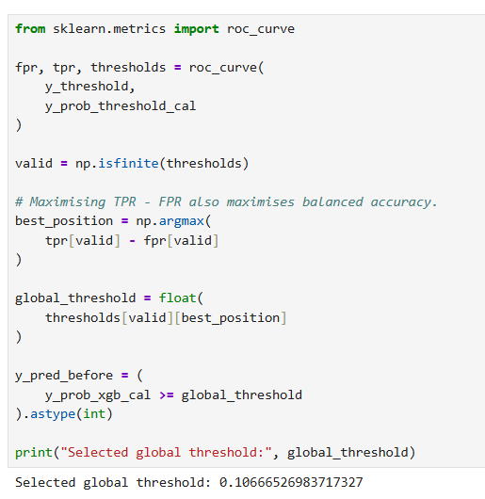

Figure 5: Global threshold seelction

Explanation Analysis
SHAP TreeExplainer is used for XGBoost. This study provides results in the form of the mean absolute SHAP importance score, waterfalls, and mean absolute contribution for subgroups based on age, gender, and race. Global ranking stability is analysed in three samples of 2,000 patient encounters each, using Spearman rank correlation and top-10 Jaccard similarity scores. Re-weighting is evaluated based on the mean absolute SHAP importance score for a 1,000 test patient encounters sample.

Ethical Consideration

Chapter – 04
Data Analysis

Data Analysis and Results

Cohort and Data Quality
The dataset used for analysis includes 101,766 encounters, out of which 11,357 <30 days readmissions occur and implemented in Python using pandas, NumPy, scikit-learn, XGBoost, InterpretML, SHAP, matplotlib and seaborn. The final dataset excludes 2,423 encounters where the code for discharge disposition in the dataset represents death or hospice care as well as the two age groups [0-10), and [10-20). There are no duplicated encounter IDs in the dataset. Hence, there are 98,493 encounters in the final dataset, out of which 11,271 are positive and 87,222 are negative (11.44% prevalence rate). The age group filtering includes patients 20 years or above.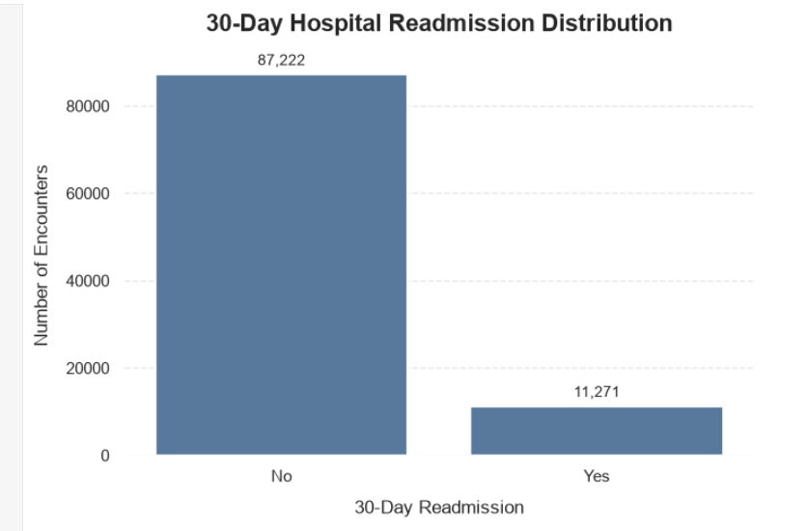
Figure 6: 30-Day Hospital Readmission Distribution
Descriptive rates are subject to the observed groups. In the final cohort, the 30-day readmission rate was found to be 11.6% for Caucasian encounters, 11.5% for African American encounters, 10.6% for Hispanic encounters, 10.4% for Asian encounters, and 9.8% for “Other”. 2273 race values are missing. 30-day readmission rates are 11.52% for female and 11.4% for male encounters. Rate of age-bands were highest for [20–30) (14.31%) and [50-60) (9.8%), while other rates were lower. Weight is 96.86% missing and hence was removed.

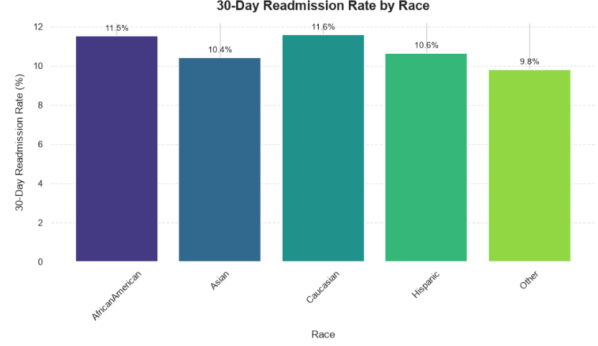
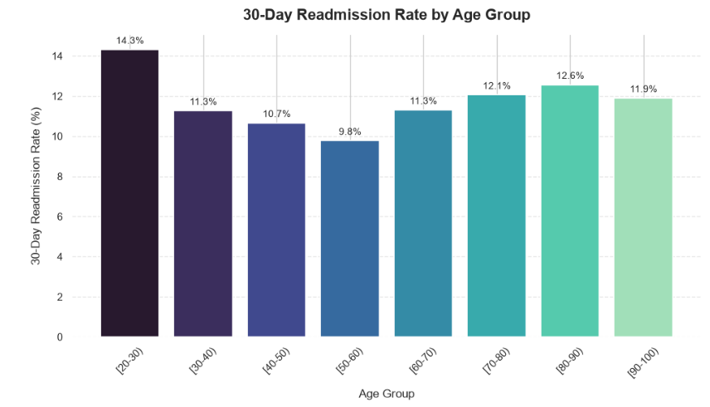
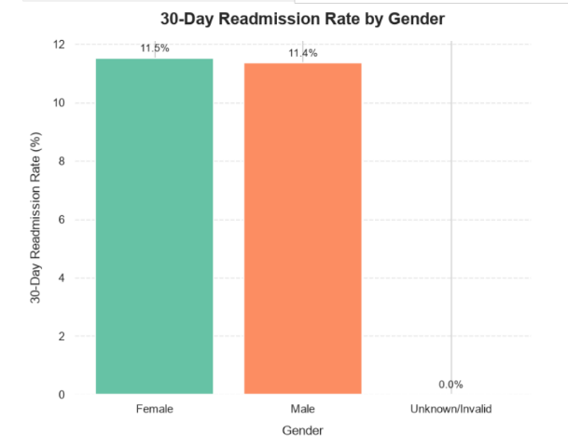
Figure 7: Descriptive readmission rates
The high rate of missing values on laboratory tests could be explained by one of the key aspects: test ordering depends on clinical judgment, available resources, and the patient’s state. The fact that a test was done correlates with readmission only and could serve as a marker in the source system, but would not be transferable to another system which uses other methods. In other words, missingness becomes the marker of clinical practice in the specific system.

Model Performance
The high rate of missing values on laboratory tests could be explained by one of the key aspects: test ordering depends on clinical judgment, available resources, and the patient’s state. The fact that a test was done correlates with readmission only and could serve as a marker in the source system, but would not be transferable to another system which uses other methods. In other words, missingness becomes the marker of clinical practice in the specific system.
Figure 8 gives the results on the hold-out test set. The XGBoost classifier using sigmoid calibration is the best-performing model based on ROC-AUC and average precision metrics, though the gap between the performances of this model and EBM, and penalized logistic regression is minimal. Average precision is used as the metric for the PR-curve instead of the ambiguously-named PR-AUC; the no-skill baseline is estimated to be the prevalence on the test set (0.1145).
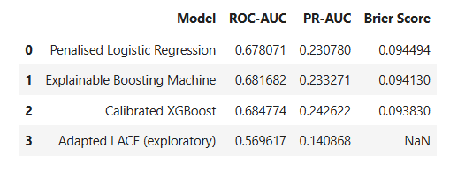
Figure 8: Final held-out performance

The last discrimination differences are small, calibrated XGBoost outperforms logistic regression with 0.0067 difference for ROC-AUC and 0.0118 difference for average precision; EBM outperforms logistic regression with 0.0036 difference for ROC-AUC and 0.0025 difference for average precision. An average precision of 0.24 is twice the positive prevalence rate, but the precision is still low at the selected operating point.
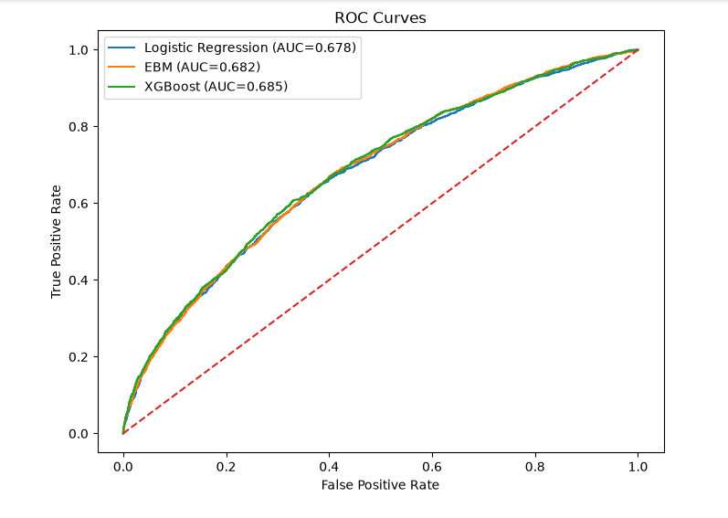
Figure 9: Held out ROC AUC curve
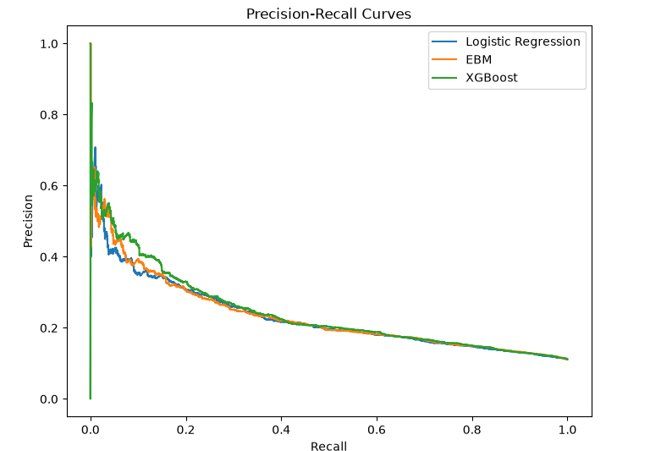

Figure 10: Held out average precision
With the default threshold of 0.5, the sensitivity is 0.6032, specificity is 0.6720, PPV is 0.1881, and NPV is 0.9308. In comparison of operating points, the globally chosen threshold of about 0.1067 is used for evaluation of performance based on the validation set. Comparison of threshold-sensitive measures should include information on threshold selection.
The model comparison needs to be considered along with the splitting and the outcome construction. The test statistic applies to the encounters from patients not included in the training set but sampled from the same historical mix of datasets. This is neither a risk estimates on a per-patient level for a future year nor proof of performance on a hospital where no development data was used. As all models are applied to the same test samples, paired comparisons would be appropriate here and may help to see if the order is significant. Comparison of the modified LACE score is even more restricted by the fact that it is constructed using proxy variables and does not yield a probability estimate. Thus, only ranking measures may be used.

Calibration
It is interesting to note the contrast between Brier score and calibration intercept and slope when comparing these models. The Brier score is an average squared error over all cases and is affected by calibration and discrimination capacity. While intercept and slope measure systematic shifts and variation in log odds predictions, they cannot detect all types of miscalibrations. One model can perform well in terms of Brier score but exhibit non-ideal slope or have problems with certain ranges of risk scores. At the same time, another model can perform well in terms of rank ordering but need recalibration of probabilities. Therefore, the results allow making only partial conclusions: the calibrated XGBoost probabilities are much better than uncalibrated ones in terms of Brier score, while EBM is close to perfect intercept and slope values. Reliability diagrams for different ranges and subgroups of risks would provide more details about errors; one should not make a conclusion about guaranteed accuracy from one aggregate score in the current project.
On the held-out test data set, penalised logistic regression has Brier score 0.09449, EBM 0.09413, raw XGBoost 0.21437 and sigmoid-calibrated XGBoost 0.09383. The calibration intercept/slope diagnostics have values of 0.2459/1.1425 for logistic regression, 0.1196/1.0809 for EBM and 0.2681/1.1567 for calibrated XGBoost, where an ideal value for both metrics is 0 and 1 respectively. EBM appears to perform the closest to the ideal on these two intercept/slope metrics while sigmoid-calibrated XGBoost has the lowest Brier score.

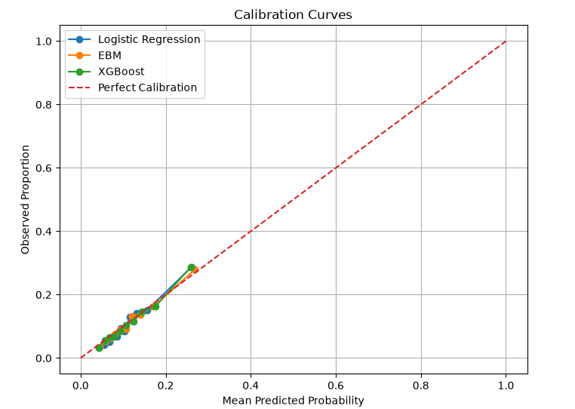

Figure 11: Calibration curves for final models

Sigmoid calibration improves the Brier score of XGBoost model from 0.21437 to 0.09383 with the same ROC-AUC (0.68477) and average precision (0.24262). This is in agreement with the fact that calibration transforms the scale of probability but preserves ranking. Although the calibrated score model does reasonably well in terms of Brier score, its calibration intercept and slope still deviate from the ideal.

Subgroup Performance and Fairness

Chapter – 05
Discussion

Discussion

Results Discussion

Comparison with previous studies

Answer Objective 1

Answer Objective 2

Answer Objective 3

Summary

Chapter – 06
Conclusion

Conclusion

Limitations

Contribution

Future work

References ( APA style )

Appendix A
  - Human Ethic Committee approval (if applicable)

  - Consent Form (if applicable)

  - Questionnaire (If Applicable)

A4 Interview Questions (If Applicable)

Glossary

